Software Design Document (SDD)
Module: ADC Driver

Version | 1.0
Authors | David Mijares, Ximena Cedillo, Xavier Clemente
Files | ADC.h / ADC.c
Target MCU | STM32F411RE (Cortex-M4)
Course | Microcontrollers and Embedded Systems — CETYS Universidad

1. Introduction

1.1. Purpose
This document describes the software design and architecture of the ADC driver module developed for the STM32F411RE microcontroller. The design is based on the following: the driver has to provide standardized functions for initializing ADC peripherals, configuring sampling channels, and retrieving digital conversion results from analog inputs in STM32 microcontrollers. The driver must be implemented in C language, portable across STM32 families supporting ADC peripherals and operate within real-time constraints. It provides details on data structures, algorithms, and control flow to guide implementation and testing.
This SDD serves as a reference for maintenance, testing, and future improvements of the ADC Control System firmware.

1.2. Scope
The ADC driver is a low-level software component for embedded systems that abstracts hardware register access and provides a clean C API. This API enables higher-level modules to work with multiple ADC instances and channels seamlessly, abstracting the underlying hardware. As a result, developers can efficiently measure analog signals—such as sensor outputs and voltage levels—for applications requiring analog signal acquisition.

1.3. Definitions and Acronyms
Term | Definition
ADC | Analog-to-Digital Converter peripheral
Channel | Input line connected to ADC multiplexer
Injected Channel | Special ADC channel triggered by external events
Resolution | Number of bits in the digital conversion result (e.g., 12-bit)
Vref | Reference voltage used for conversion scaling
CRx | Control Register (e.g., CR1, CR2)
Continuous Conversion | Mode in which the ADC automatically starts a new conversion immediately after the previous one completes, without requiring repeated software triggers.
Single Conversion | Mode in which the ADC performs one conversion per trigger (software or external) and then stops, waiting for the next trigger to start again.

1.4. Requirements
All functional requirements implemented in ADC.h / ADC.c are listed below.
Req. ID | Type | Function | Description
FR-1 | Functional | adc_init() | The system shall enable clocking and configure all ADC peripherals to a default state.
FR-2 | Functional | adc_enableAdc() | The system shall activate the ADC for conversions.
FR-3 | Functional | adc_setChannel() | The system shall allow selection of valid channels.
FR-4 | Functional | adc_setInjectedChannel() | The system shall allow selection of valid injected channels.
FR-5 | Functional | adc_startSingleConversion() | The system shall begin conversion and set status flags.
FR-6 | Functional | adc_startContinuousConversion() | The system shall repeatedly convert input signals until stopped.
FR-7 | Functional | adc_startInjectedConversion() | The system shall trigger conversion based on external events.
FR-8 | Functional | adc_readData() | The system shall return the digital value corresponding to the analog input.
FR-9 | Functional | adc_readInjectedChannelData() | The system shall return the digital value for the specified injected channel.

2. System Architecture

2.1. High-Level Design
- Layered Architecture:
  - Application Layer: Calls ADC driver functions.
  - ADC Driver Layer: Provides APIs (adc_init, adc_enableADC, adc_setChannel, etc.).
  - Hardware Layer: STM32F411RE microcontroller ADC registers (CR1, CR2, SQRx, SMPRx, SR, DR).

2.2. Module Interfaces
- Public API: Functions declared in ADC.h
- Dependencies: stm32f4xx.h (CMSIS for register definitions), stdint.h (standard integer types)

3. Detailed Design

3.1. Class Diagram

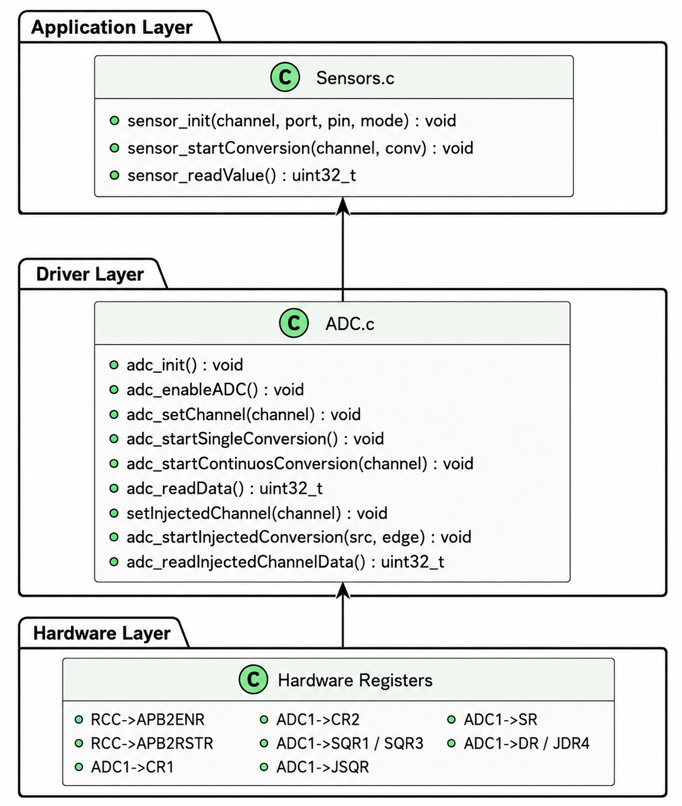
Figure 1. Class Diagram Driver

3.2. Module Behavior — Overview Diagrams
The following sequence and state diagrams illustrate the overall system behavior.
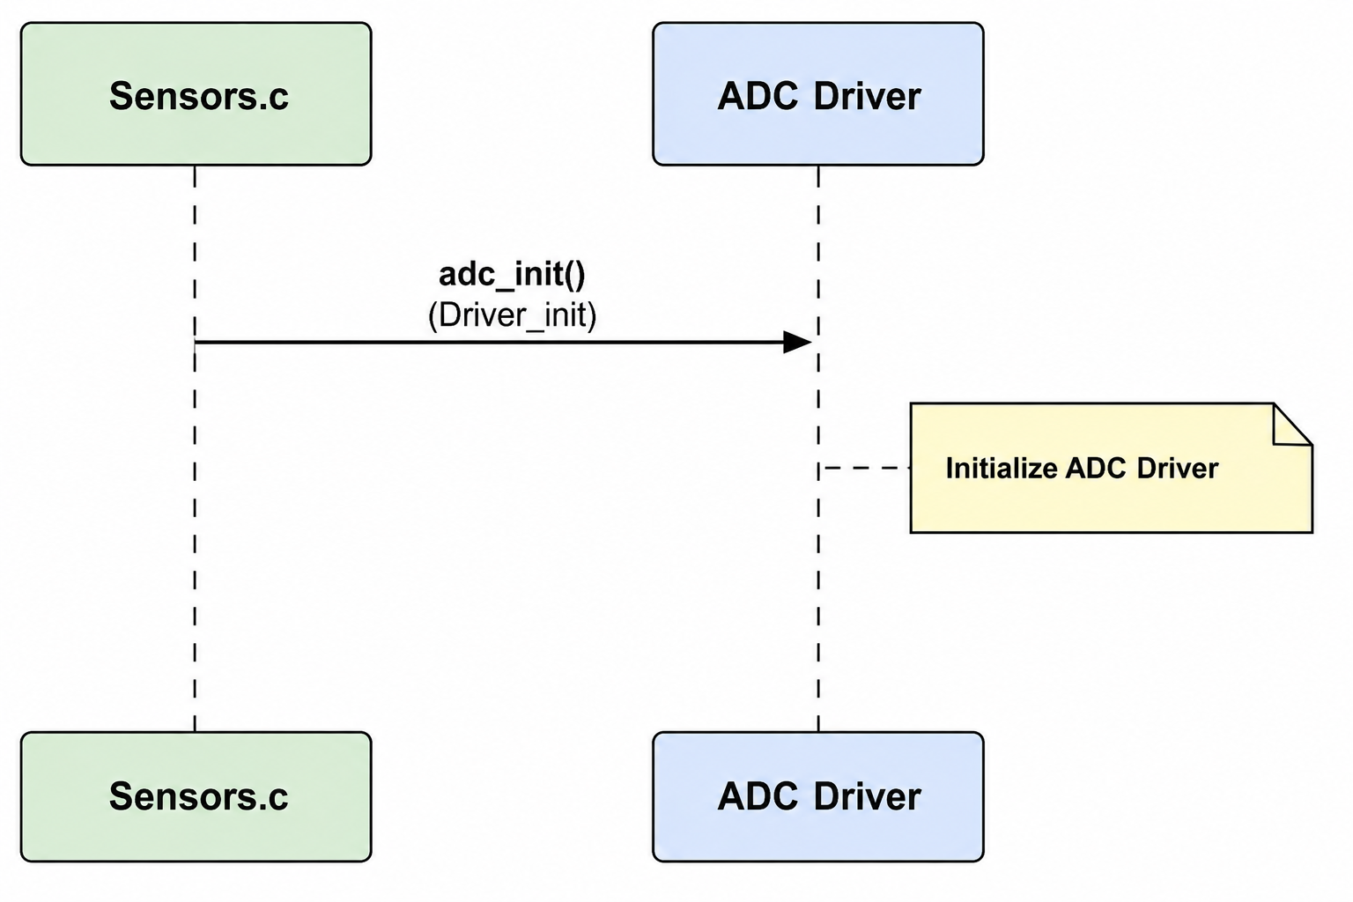
Figure 2. Sequence Diagram - ADC driver Init

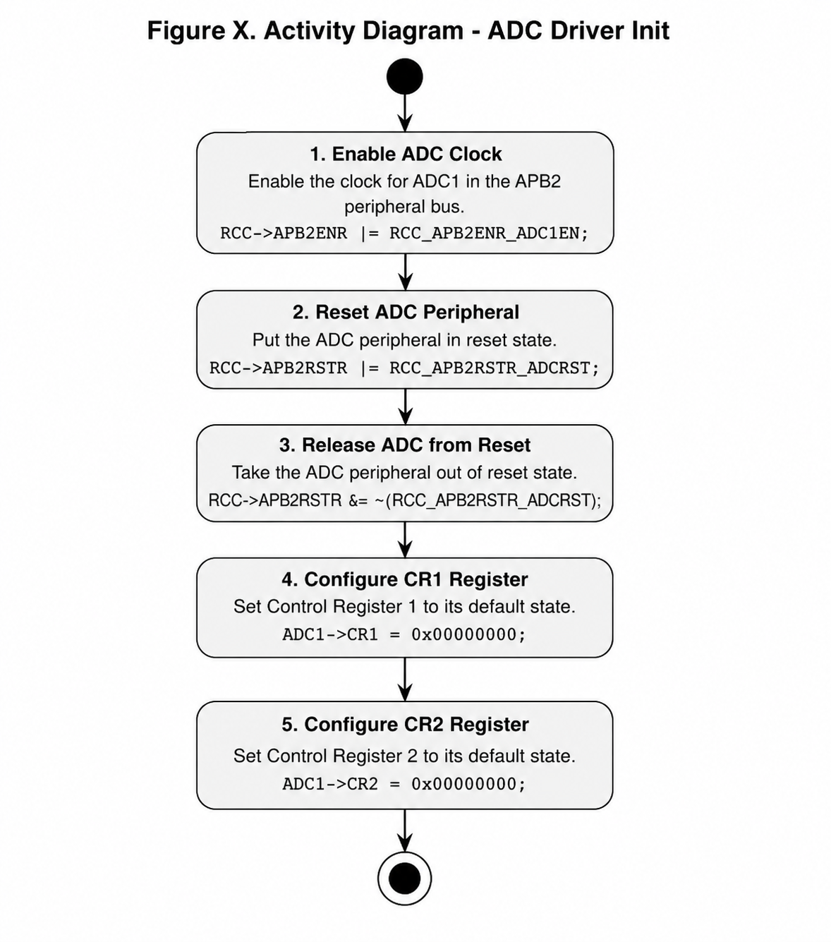
Figure 3. Activity Diagram - ADC Driver Init
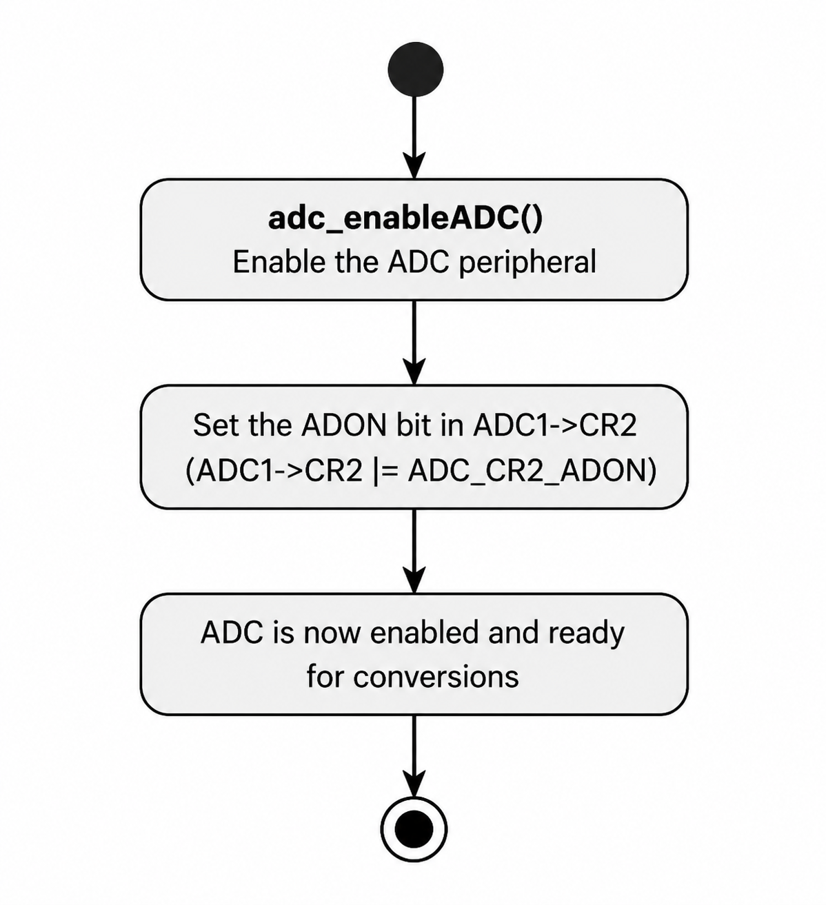
Figure 4. Activity Diagram - ADC Enable

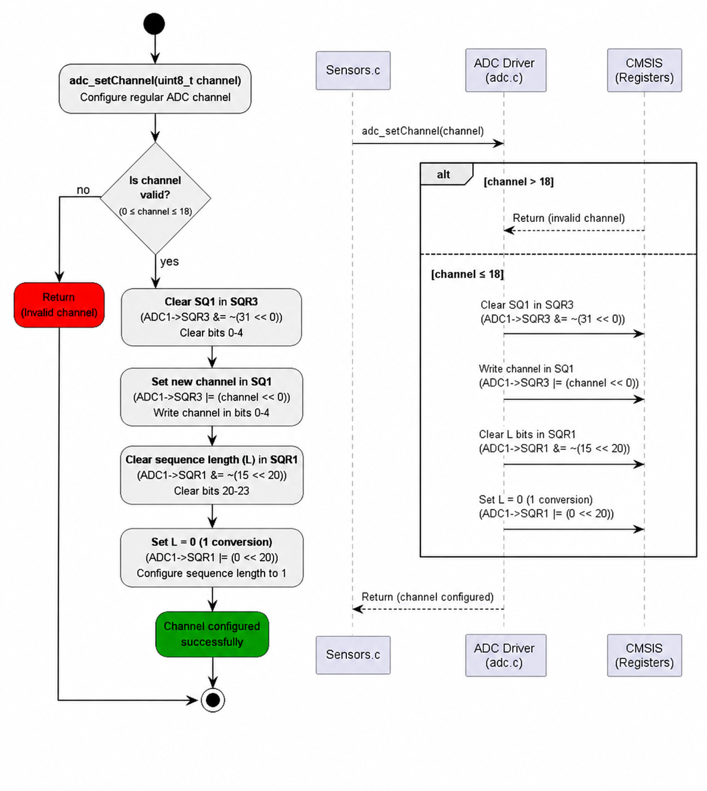
Figure 5. Sequence Diagram - ADC Set Channel

Figure 6. Activity Diagram - ADC Set Channel

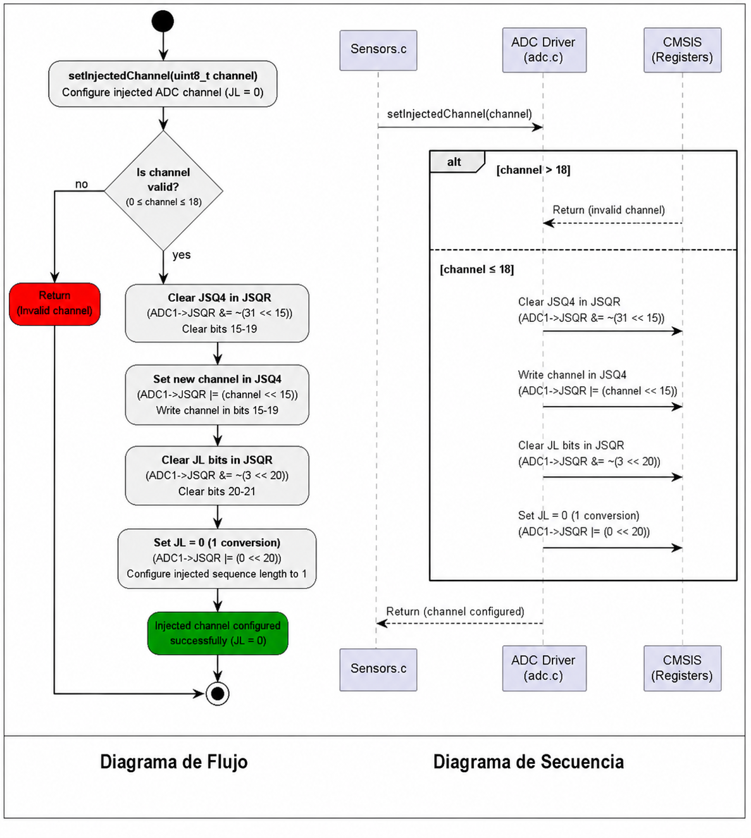
Figure 7. Sequence Diagram - ADC Set Injected Channel

Figure 8. Activity Diagram - ADC Set Injected Channel

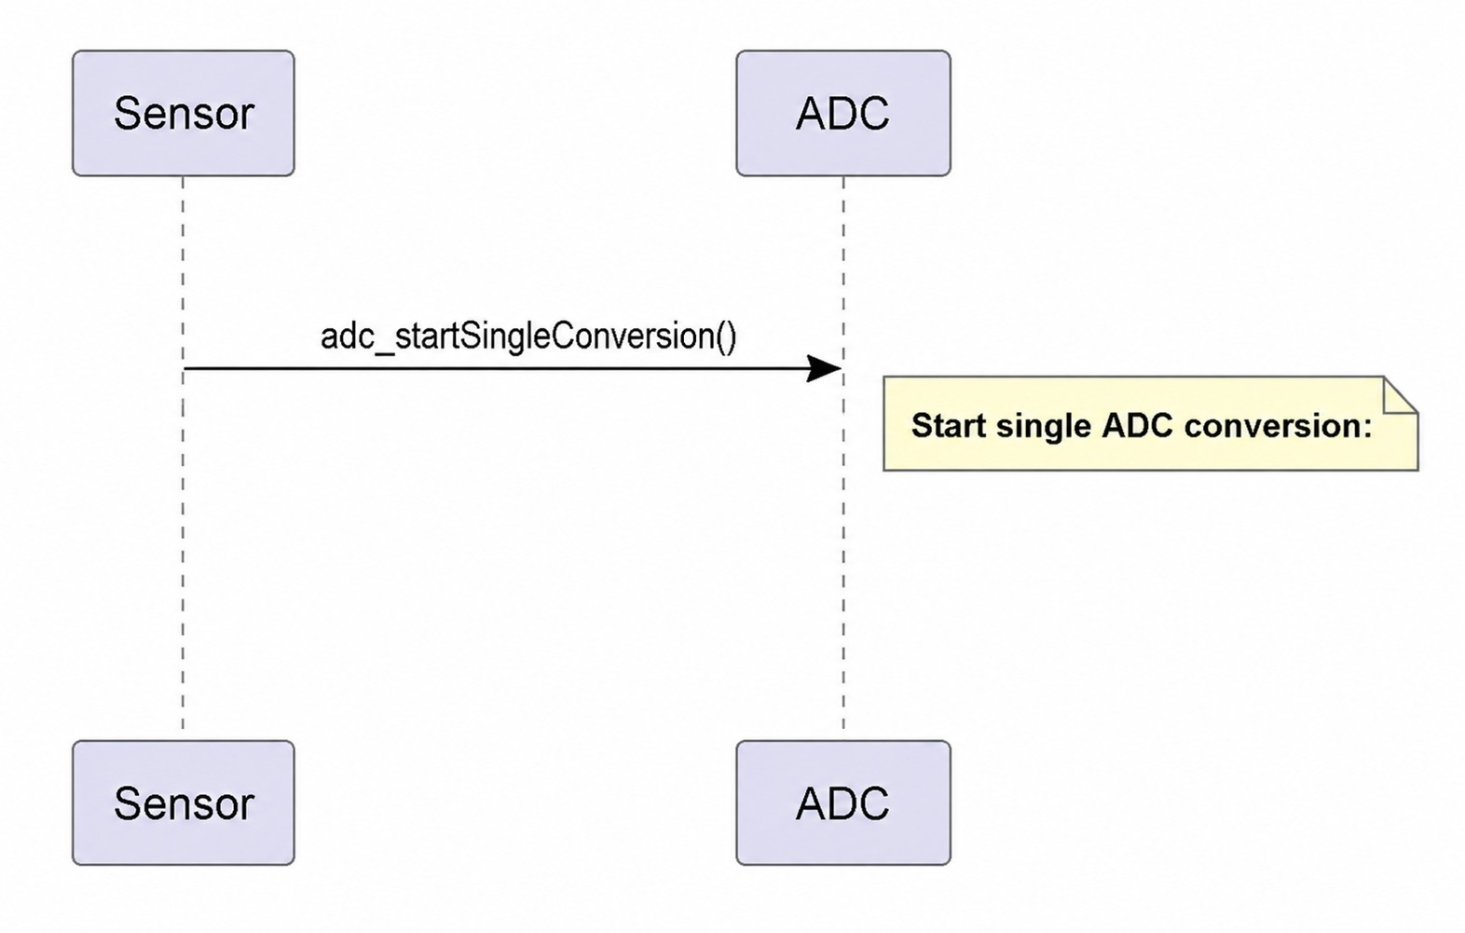
Figure 9. Sequence Diagram - ADC Start Single Conversion
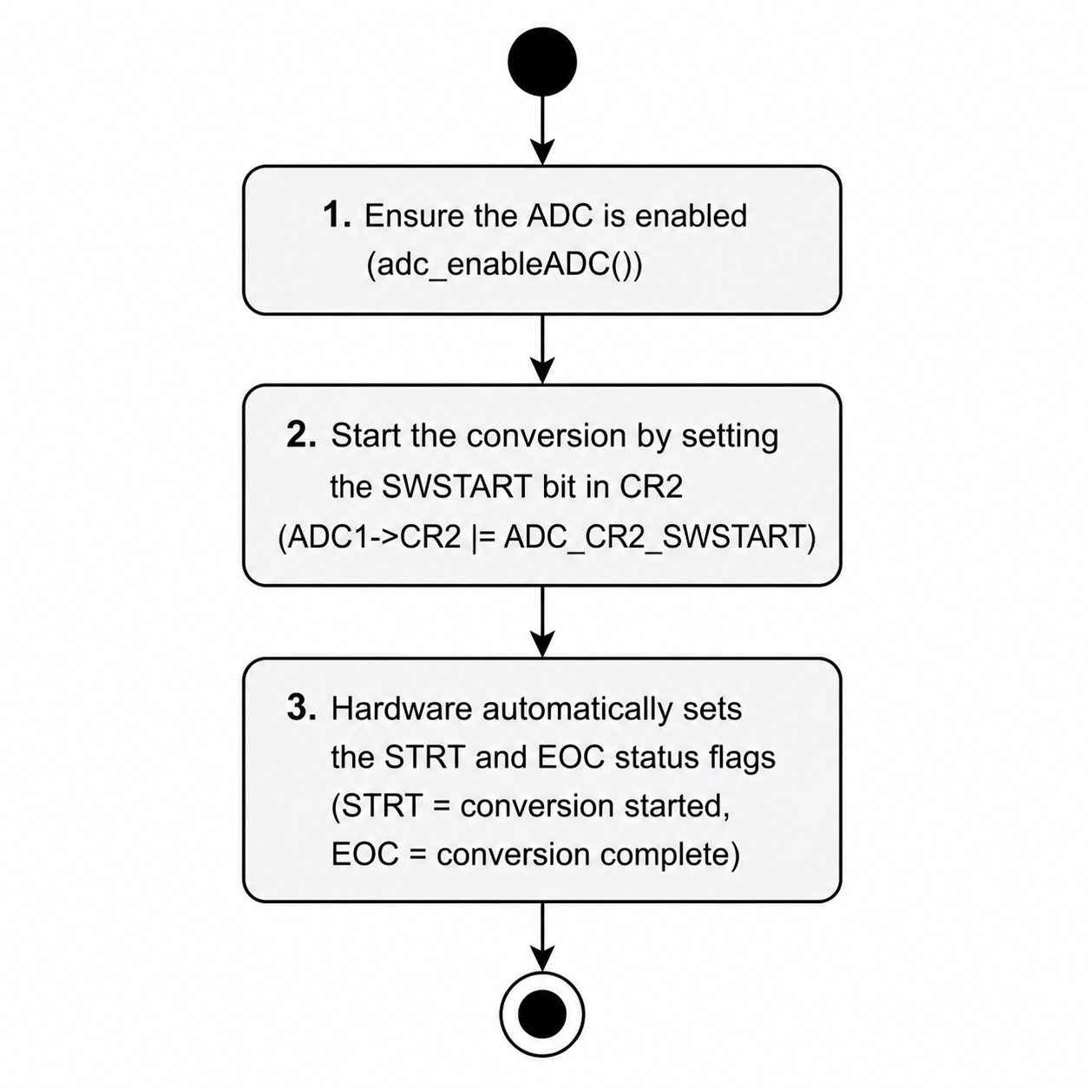
Figure 10. Activity Diagram - ADC Start Single Conversion

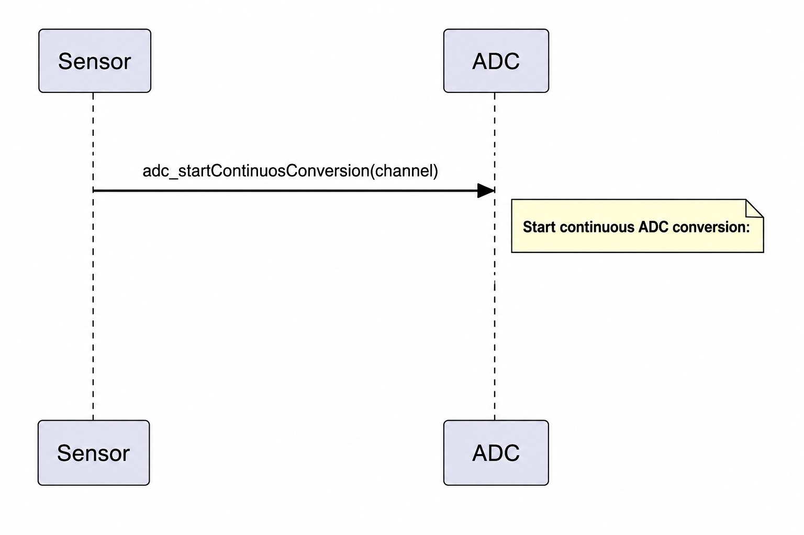
Figure 11. Sequence Diagram - ADC Continuous Conversion
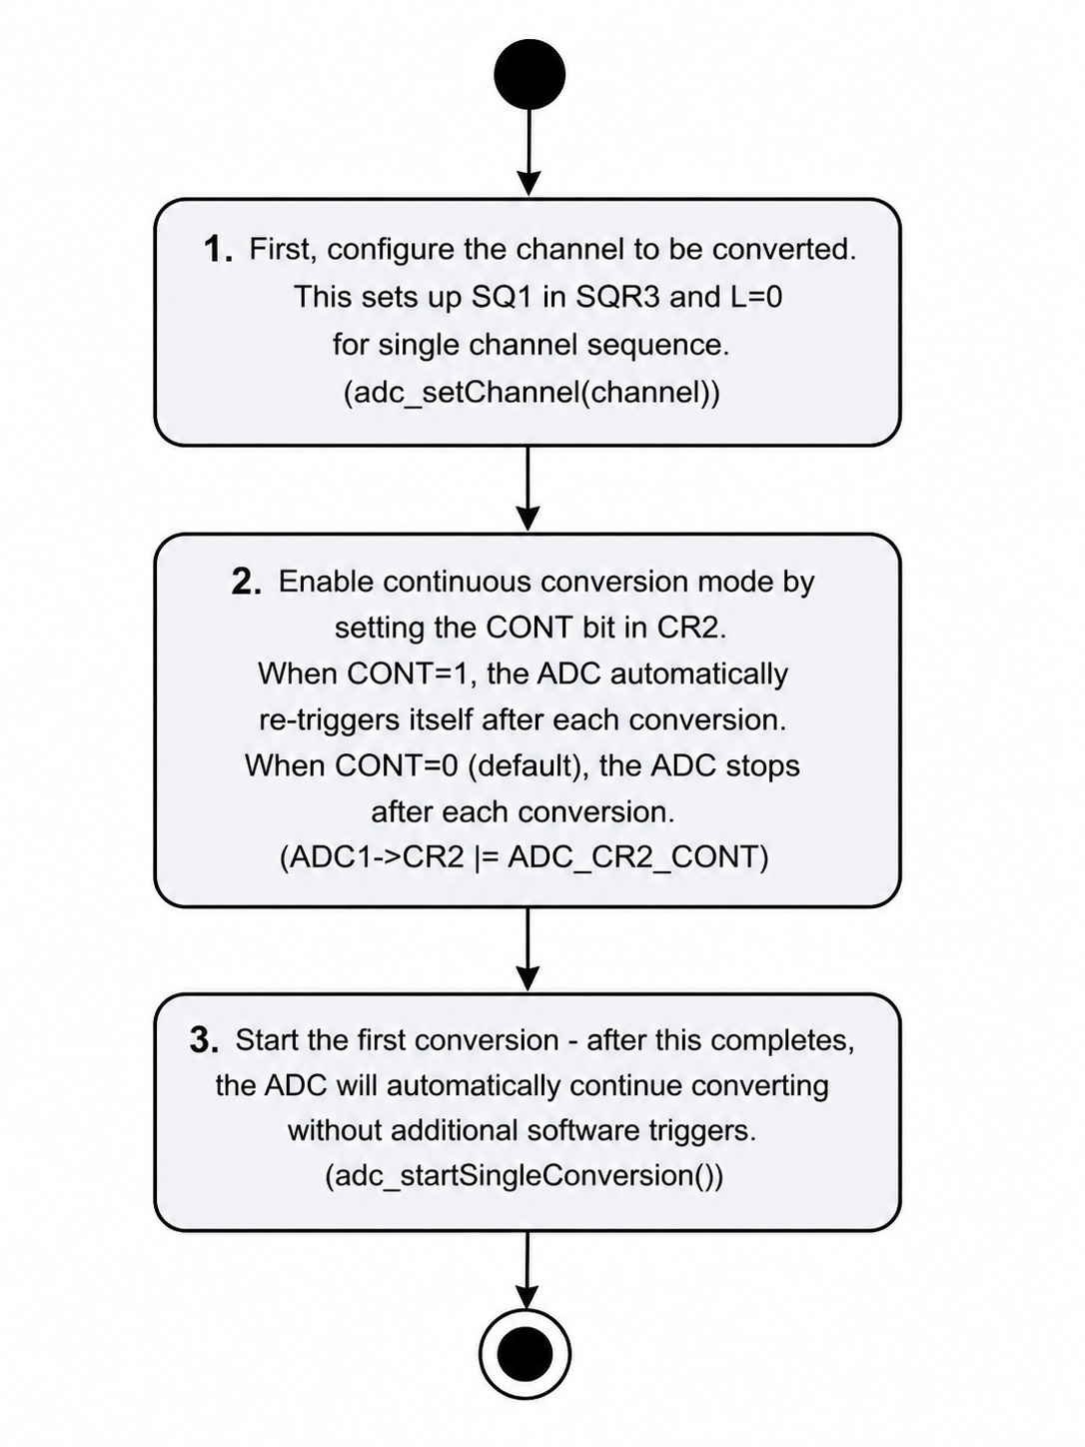
Figure 12. Activity Diagram - ADC Continuous Conversion

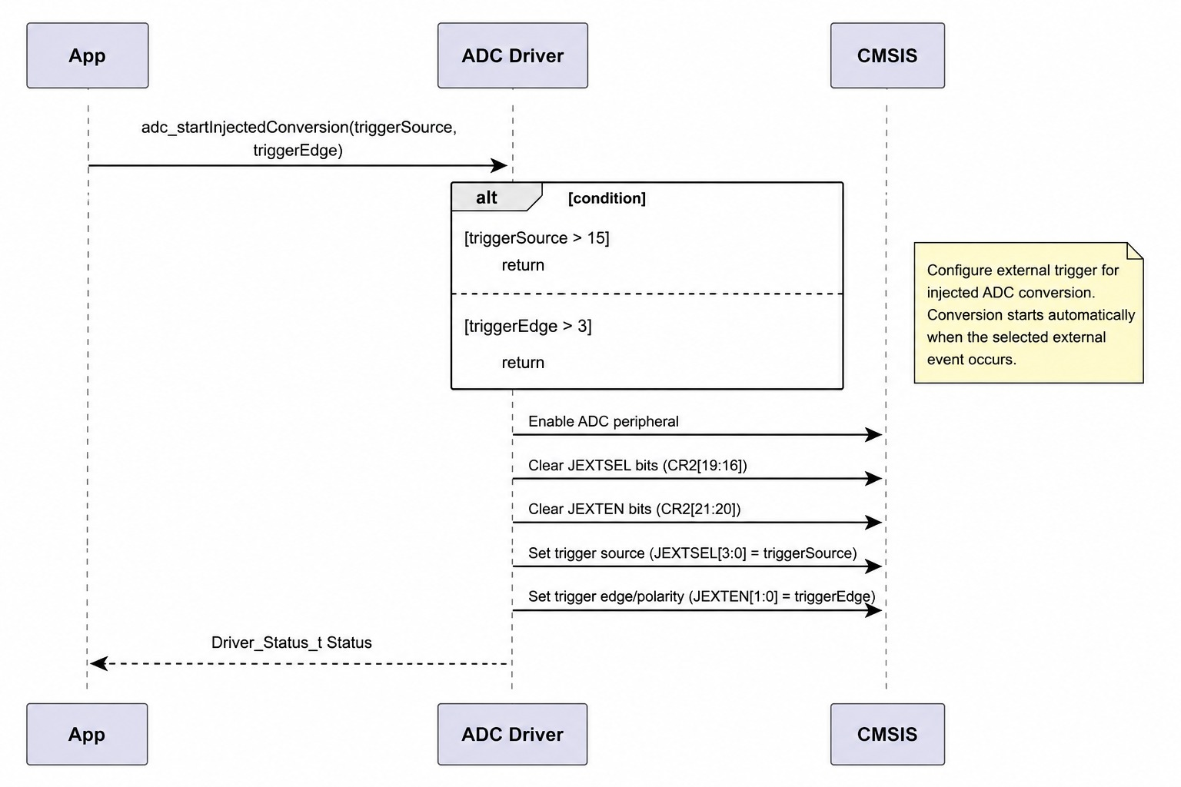
Figure 13. Sequence Diagram - ADC Injected Conversion
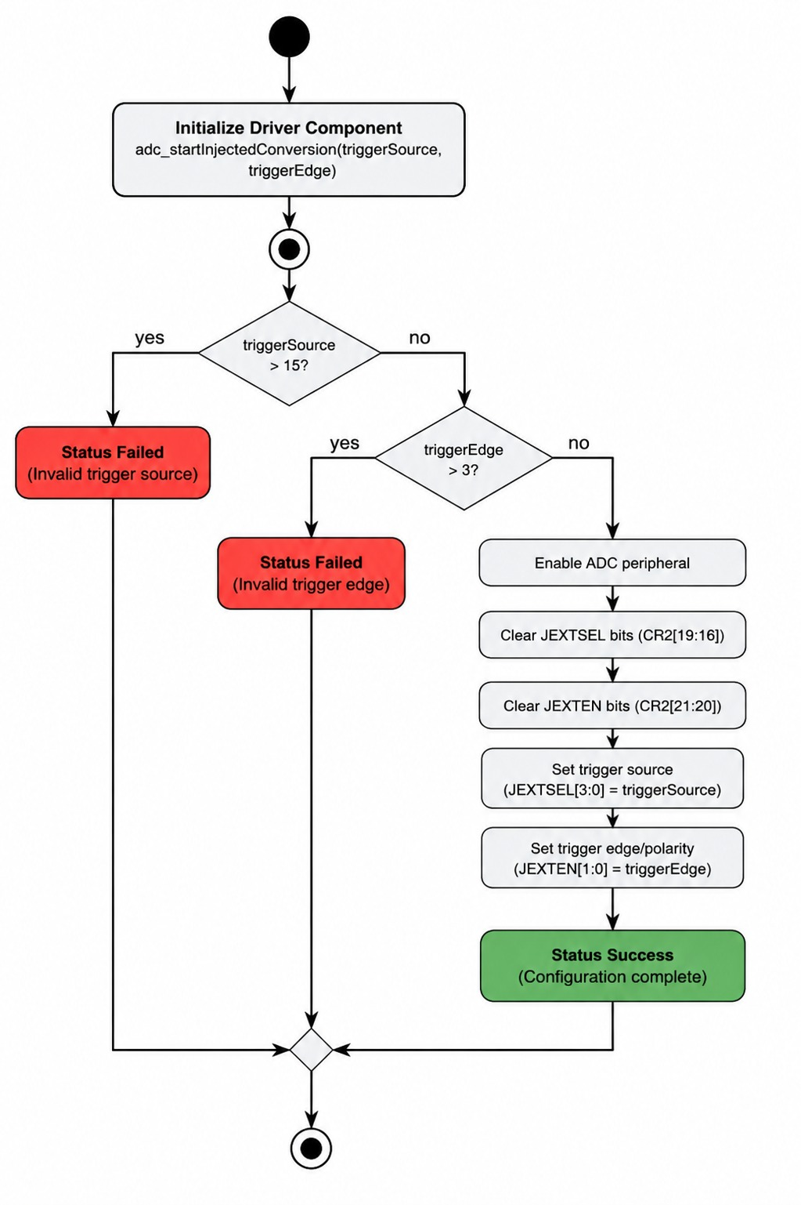
Figure 14. Activity Diagram - ADC Injected Conversion
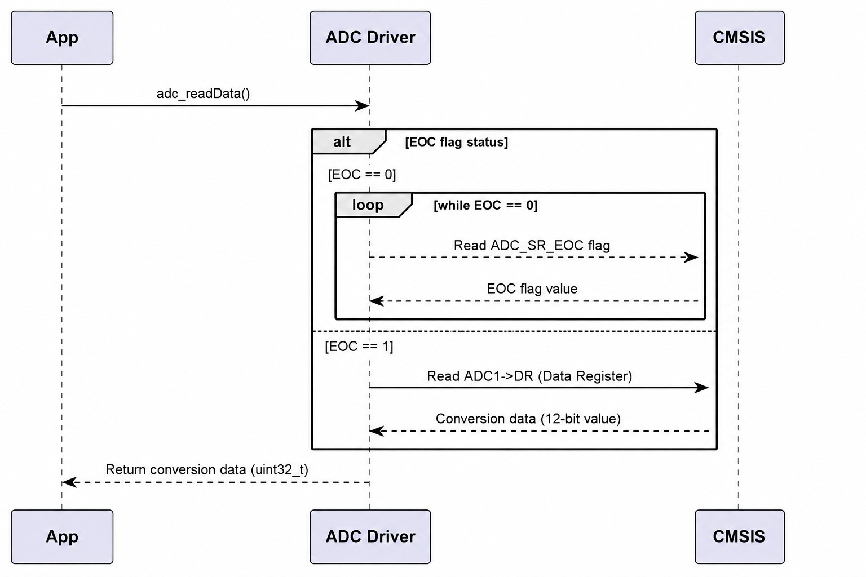
Figure 15. Sequence Diagram - ADC Read Data
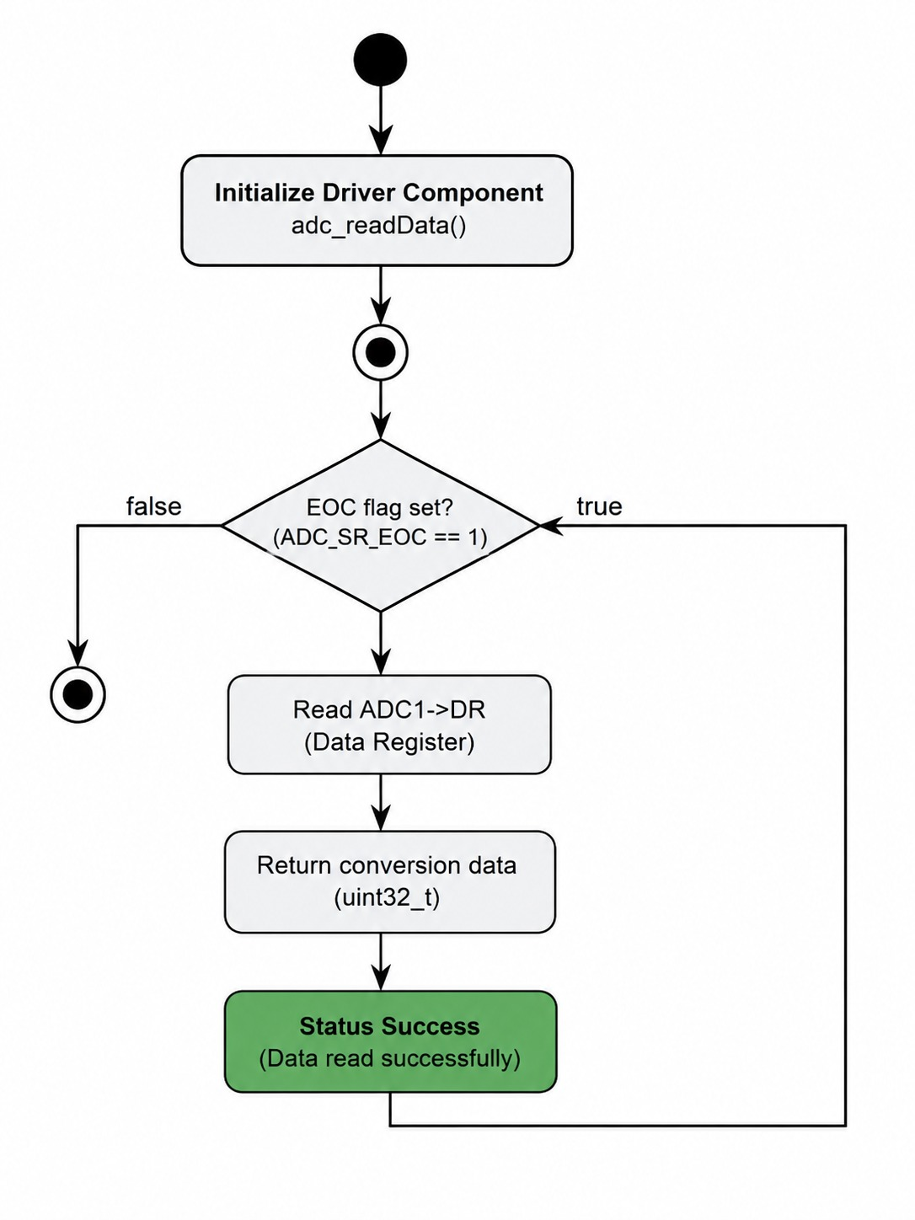
Figure 16. Activity Diagram - ADC Read Data
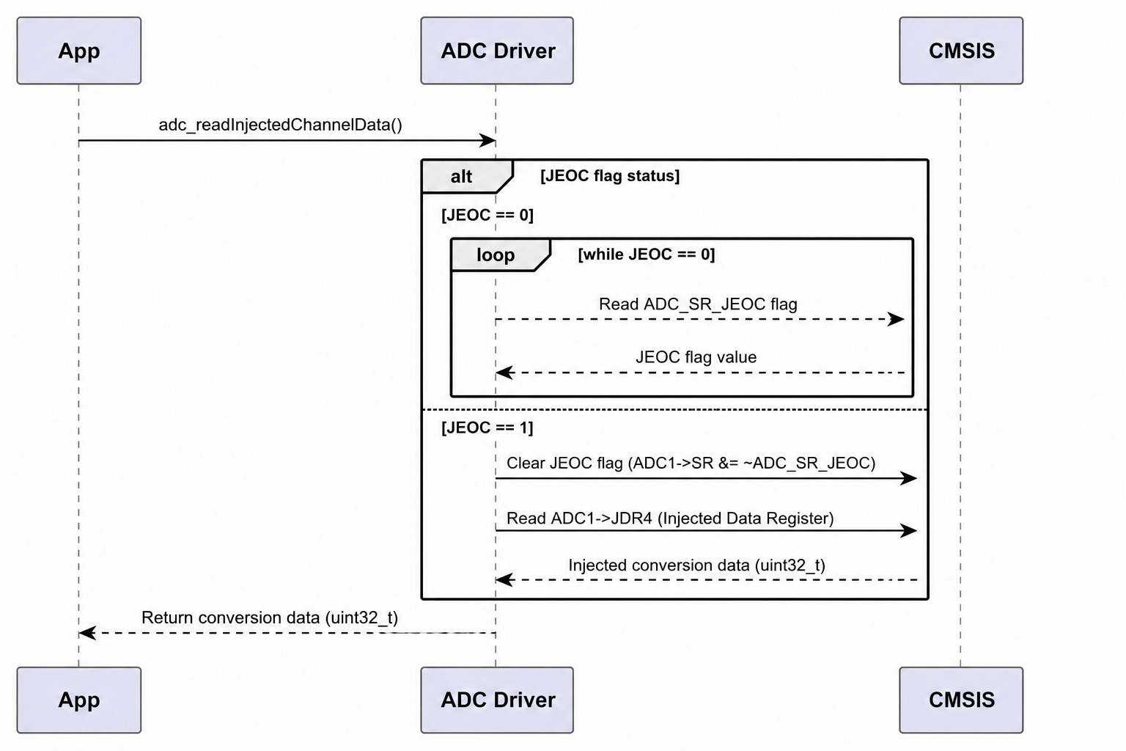
Figure 17. Sequence Diagram - ADC Read Injected Data
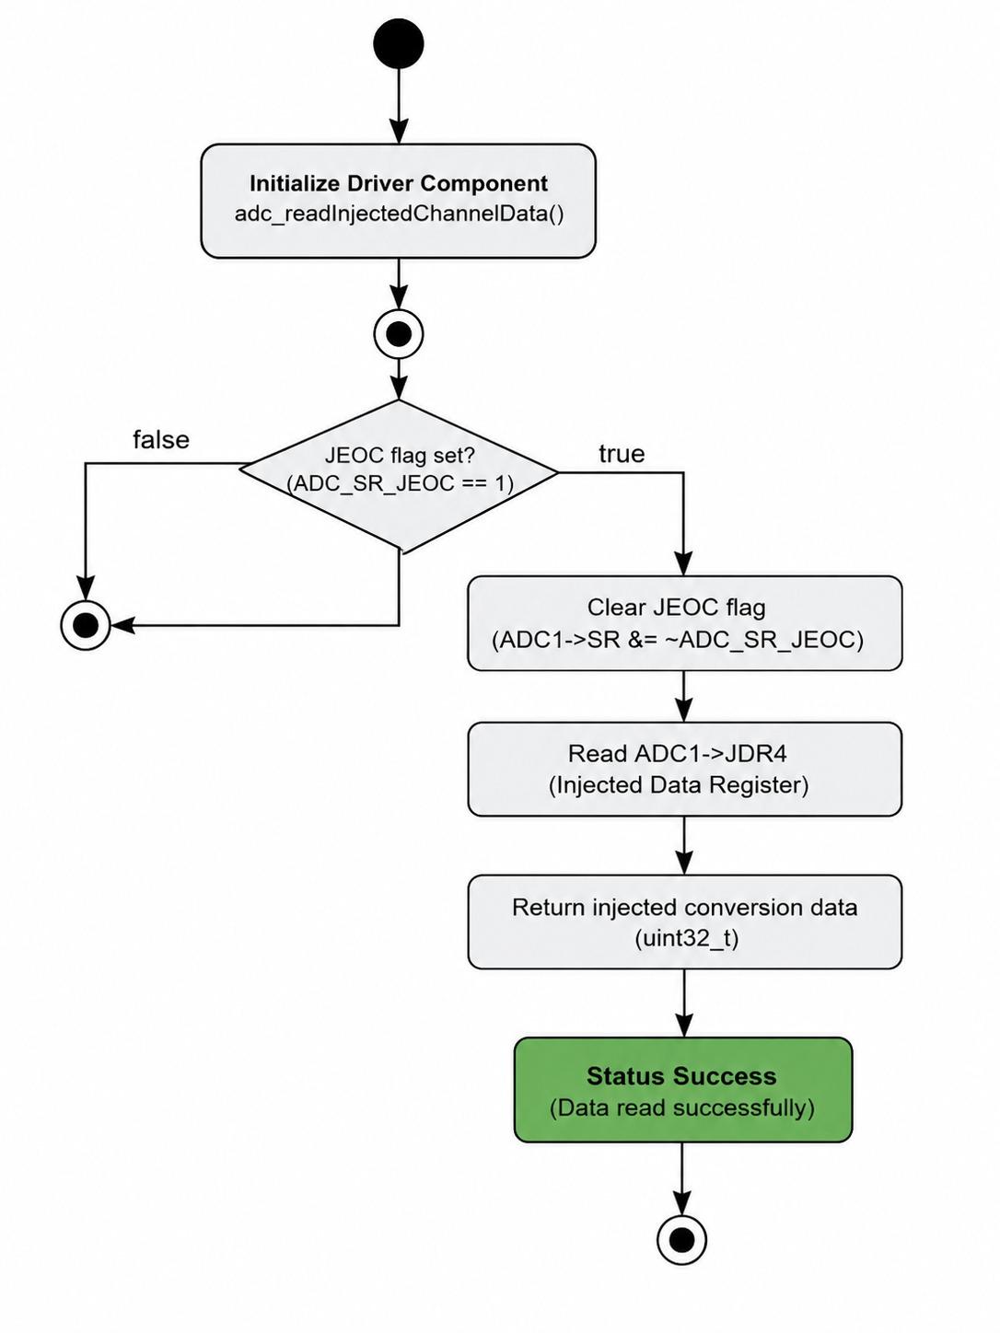
Figure 18. Sequence Diagram - ADC Read Injected Data

3.3. ADC Driver
The ADC driver acts as an intermediate layer between the application and the microcontroller hardware. Its main purpose is to abstract direct register access, allowing the application to request conversions or read data without dealing with low-level details. In the diagrams, this interaction is clearly shown: the App calls functions in the Driver, and the driver communicates with the hardware through CMSIS, manipulating ADC registers directly.
The conversion start functions control how the ADC is triggered. For a single conversion, the driver simply enables the ADC and sets the software start bit. In continuous mode, it first configures the channel, enables continuous conversion, and then starts the first conversion, after which the hardware automatically continues converting. For injected conversions, the driver does not start the conversion directly; instead, it configures an external trigger source and its polarity, so the conversion begins when the corresponding hardware event occurs.
The read functions implement a polling mechanism based on status flags. For regular conversions, the driver waits until the EOC (End Of Conversion) flag is set before reading the data register. For injected conversions, it waits for the JEOC flag, clears it manually, and then reads the result from the injected data register. In the flow diagrams, this behavior is represented as a loop that continues until the condition is met, followed by reading and returning the value.
Overall, the driver design clearly separates responsibilities: some functions handle configuration and conversion startup, while others manage data retrieval. This modular approach simplifies ADC usage, improves code readability, and allows the application to interact with the hardware in a controlled and structured way.

4. Application Programming Interfaces

4.1. Data Types and Macros
- uint8_t: This data type represents 8-bit unsigned integer values used in the ADC driver for:
  - Channel selection (0–18)
  - Trigger source selection (0–15)
  - Trigger edge configuration (0–3)
- uint32_t: This data type represents 32-bit unsigned integer values used for:
  - ADC conversion results
  - Peripheral register access and manipulation
This driver does not define custom structures, but it uses CMSIS-defined structures to interact with hardware.
- ADC_TypeDef (CMSIS): This structure represents the ADC peripheral and contains all registers required for configuration and operation.
Member name | Type | Notes / Definition
CR1 | uint32_t | Control Register 1 (basic ADC configuration)
CR2 | uint32_t | Control Register 2 (conversion control and enable)
SR | uint32_t | Status Register (flags such as EOC, JEOC)
DR | uint32_t | Data Register (regular conversion result)
SQR1 | uint32_t | Regular sequence register 1
SQR3 | uint32_t | Regular sequence register 3 (channel selection)
JSQR | uint32_t | Injected sequence register
JDR4 | uint32_t | Injected data register

- RCC_TypeDef (CMSIS): This structure controls the clock system and peripheral reset.

Member Name | Type | Notes / Definition
APB2ENR | uint32_t | Peripheral clock enable register (ADC clock)
APB2RSTR | uint32_t | Peripheral reset register
- RCC_APB2ENR_ADC1EN: This macro enables the clock for ADC1.
  - Value: Defined in CMSIS (specific bit in APB2ENR register)
- RCC_APB2RSTR_ADCRST: This macro controls the reset of the ADC peripheral.
  - Value: Reset bit in APB2RSTR
- ADC_CR2_ADON: This macro enables the ADC.
  - Value: ADON bit in CR2 register
- ADC_CR2_SWSTART: This macro starts a conversion via software.
  - Value: SWSTART bit in CR2
- ADC_CR2_CONT: This macro enables continuous conversion mode.
  - Value: CONT bit in CR2
- ADC_SR_EOC: This macro indicates End Of Conversion (regular channel).
  - Value: EOC flag in SR register
- ADC_SR_JEOC: This macro indicates End Of Conversion for injected channels.
  - Value: JEOC flag in SR register

4.2. Error Codes
The ADC driver APIs currently do not return explicit error codes, as most functions are defined with a void return type and use internal validation (early return) for error handling.
However, based on the implemented validation logic, the following conceptual error codes can be defined to standardize the driver behavior.

4.3. Function Definitions
- adc_init
Field | Description
Function Name | adc_init
Syntax | void adc_init(void)
Parameters (in) | None
Parameters (inout) | None
Parameters (out) | None
Return value | void
Description | Initializes the ADC peripheral by enabling its clock, resetting the module, and configuring control registers to default values
Constraints | Does not report initialization errors
Available | ADC.h

- adc_enableADC
Field | Description
Function Name | adc_enableADC
Syntax | void adc_enableADC(void)
Parameters (in) | None
Parameters (inout) | None
Parameters (out) | None
Return value | void
Description | Enables the ADC peripheral by setting the ADON bit in the control register
Constraints | Must be called before starting a conversion
Available | ADC.h
- adc_setChannel
Field | Description
Function Name | adc_setChannel
Syntax | void adc_setChannel(uint8_t channel)
Parameters (in) | channel
Parameters (inout) | None
Parameters (out) | None
Return value | void
Description | Configures the selected ADC channel as the first conversion in the regular sequence
Constraints | If channel > 18, the function exits without configuration
Available | ADC.h

- setInjectedChannel
Field | Description
Function Name | setInjectedChannel
Syntax | void setInjectedChannel(uint8_t channel)
Parameters (in) | channel
Parameters (inout) | None
Parameters (out) | None
Return value | void
Description | Configures an injected ADC channel for conversion
Constraints | If channel > 18, no configuration is performed
Available | ADC.h
- adc_startSingleConversion
Field | Description
Function Name | adc_startSingleConversion
Syntax | void adc_startSingleConversion(void)
Parameters (in) | None
Parameters (inout) | None
Parameters (out) | None
Return value | void
Description | Starts a single ADC conversion using software trigger
Constraints | ADC must be enabled before conversion
Available | ADC.h

- adc_startContinuosConversion
Field | Description
Function Name | adc_startContinuosConversion
Syntax | void adc_startContinuosConversion(uint8_t channel)
Parameters (in) | channel
Parameters (inout) | None
Parameters (out) | None
Return value | void
Description | Configures and starts continuous conversion mode for a selected channel
Constraints | Requires a valid channel number
Available | ADC.h
- adc_startInjectedConversion
Field | Description
Function Name | adc_startInjectedConversion
Syntax | void adc_startInjectedConversion(uint8_t triggerSource, uint8_t triggerEdge)
Parameters (in) | triggerSource, triggerEdge
Parameters (inout) | None
Parameters (out) | None
Return value | void
Description | Configures and starts injected ADC conversion using external trigger
Constraints | Invalid parameters result in no operation
Available | ADC.h

- adc_readData
Field | Description
Function Name | adc_readData
Syntax | uint32_t adc_readData(void)
Parameters (in) | None
Parameters (inout) | None
Parameters (out) | None
Return value | uint32_t
Description | Waits until conversion is complete and returns the result from the data register
Constraints | Blocking function (waits indefinitely until conversion completes)
Available | ADC.h
- adc_readInjectedChannelData
Field | Description
Function Name | adc_readInjectedChannelData
Syntax | uint32_t adc_readInjectedChannelData(void)
Parameters (in) | None
Parameters (inout) | None
Parameters (out) | None
Return value | uint32_t
Description | Waits for injected conversion to complete and returns the result from JDR4
Constraints | Blocking function; manually clears JEOC flag
Available | ADC.h
4.4. Internal Function Definitions
This module does not explicitly define internal (static) helper functions. However, the following internal operations are performed within public APIs and are documented here for clarity.

5. Future Enhancements
The current ADC driver provides basic functionality for initialization, configuration, and data acquisition. However, several improvements can be implemented to enhance performance, scalability, and robustness.
- Error Handling and Status Reporting
  - Introduce standardized return types (e.g., adc_status_t)
  - Provide detailed error codes for invalid parameters and runtime failures
  - Allow the application layer to detect and handle errors properly
- Non-Blocking Operation
  - Replace polling-based mechanisms with interrupt-driven conversions
  - Implement callback functions for conversion completion
  - Improve CPU efficiency by avoiding busy-wait loops
- DMA Support
  - Integrate Direct Memory Access (DMA) for high-speed data transfer
  - Enable continuous data acquisition without CPU intervention
  - Improve performance in real-time applications
- Multi-Channel Support
  - Extend driver to support multiple channels in sequence
  - Configure full scan mode instead of single-channel operation
  - Allow configurable sequence length (SQR1 register)
- Configuration Abstraction
  - Create configuration structures (e.g., adc_config_t)
    - Allow flexible setup of:
    - Resolution
    - Sampling time
    - Alignment
    - Trigger sources
  - Improve reusability and scalability
- Timeout Mechanisms
  - Add timeout handling for polling loops (EOC, JEOC)
  - Prevent infinite blocking in case of hardware failure
  - Improve system reliability
- Power Management Features
  - Support low-power modes
  - Enable/disable ADC dynamically based on system needs
  - Reduce energy consumption in embedded systems
- Calibration and Accuracy Improvements
  - Implement ADC calibration routines
  - Improve measurement accuracy
  - Support temperature sensor and internal reference calibration
- Code Modularity and Internal APIs
  - Refactor code to include static internal helper functions
  - Improve readability and maintainability
  - Separate validation, configuration, and execution logic
- Documentation and Standardization
  - Align driver with embedded standards (e.g., HAL-style or AUTOSAR-like structure)
  - Improve API documentation consistency
  - Add usage examples and diagrams

